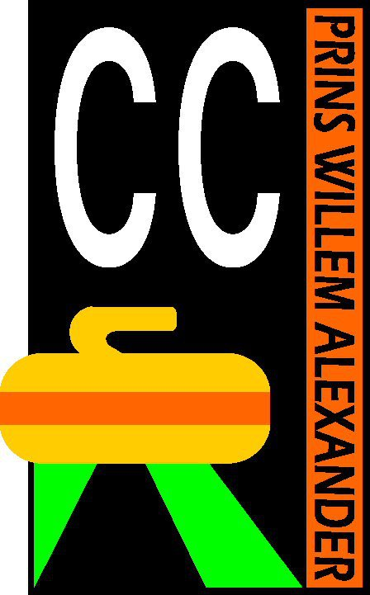
SIGN UP FORM
Adult- or student membership
Curling Club Prins Willem-Alexander
Signator signs up for a membership at Curling Club Prins Willem-Alexander

First name: ……………………………………. Initials:………..………….

Last name: ………….……………………………………………………………………

Address .………………………………………………………………………………………

Postcode: …………………… City: ……………………………..……

Sex: M / W Date of birth: …………………………………….

Phone # mobile: …………………………………………………..

Phone # home: .………………………………………….

E-mail ……………………………………………………….……………………………..

Other (e.g. Food restrictions):
…………………………..………………………………………………………………….

The club is always looking for volunteers to help during club activities, would you be able to do this in any way? Yes / No

Memberships:

 | Price | Youth activities | Monday afternoon  OR  Wednesday evening | Monday afternoon  AND  Wednesday evening | WNL | Opkras-toernooi | NCB membership
Student-membership | € 155 | - | V | V | V | V | V
Adult  * | € 110 | - | max. 4 times | - | - | V | V
Adult  ** | € 150 | - | Max. 10 times | - | V | V | V
Adult  *** | € 210 | - | V | - | V | V | V
Adult  **** | € 240 | - | V | V | V | V | V

Name: ………………………………………………………..

Chooses the following membership (prioces season 2019/2020):

Student:
- Wednesday evening student membership € 155,00
Adults:
- 1-star Monday afternoon € 110,00
- 1-star Wednesday evening € 110,00
- 2-star Monday afternoon € 150,00
- 2-star Wednesday evening € 150,00
- 3-star Monday afternoon € 210,00
- 3-star Wednesday evening € 210,00
- 4-star membership (Monday afternoon and Wednesday evening) € 240,00
Wednesday Night League (WNL, info on website www.ccpwa.nl)
- (Included for 2-4 star members and student members)
Date: ………………………….
Signature: ……………………………….……….

Please scan and mail this form to curling@ccpwa.nl or hand it over to one of the trainers/commissioners.
- The season starts on September 1st and ends on March 31st
- Ages are calculated from june 30th
- After signing up, you will receive a message about contribution. The club contribution must be paid at the most 4 weeks after sign up. Please transfer the full amount to NL77ABNA0427586232 t.n.v. Curling club PWA. After paying the club contribution you will be an official member of CCPWA and the national curling association (NCB)
- If you sign up after the starting date of the season, contributions will be calculated accordingly, you only pay for what you get.
- Your membership will be automatically renewed on September 1st every year.
- If you would like to cancel your membership renewal, you need to do so before September 1st by an email to curling@ccpwa.nl
- The information on this form will be treated confidentially.
- Our trainers should know about any handicaps or illnesses that could pose a threat to your or other’s safety on the ice (e.g. epilepsy) so they can take precautions and provide you with the help you need. Please let the trainers know personally.

